|  |  |
| --- | --- |
| Use case | Description |
| Look up clothing or product information | Using clothing, material, style, or designer's name. |
| Select the service type | Selecting buying, correcting, or making a garment. |
| Enter/update contact information (customer) | Enter (new) or update (existing) contact information |
| Enter/update contact information (partner) | Enter (new) or update (existing) contact information |
| Verify product image or short video | See if the video is appropriate for the viewer. |
| Filter searching for products | Be able to select options |
| Enter/update the clothing or product information | Enter (new) or update (existing) product. |
| Request tailor | Send request, select partner, sizes, and special instructions |
| Upload product image/video | Upload image or video of the merchandise product |
| Look up contact | Using contact name, find contact information |
| Request making new garment | Send request, select partner, sizes, fabric, types, possible photo, and special instructions |
| Purchase a garment from the warehouse | Add the product into cart, enter credit card information and delivery information. |
| Request assistance | Needing assistance from customer service via phone, email or chat. |
| Provide assistance | Providing assistant by customer service via phone, email or chat. |
| Document all conversation | Record all the conversation via phone, email or chat. |

|  |  |
| --- | --- |
| Object classes | Attribute |
| Customer | Customer name, address, and contact information. |
| Product | Description, type, material, style, quantity, rating, name, size, and type of service. |
| Partner | Partner’s name, address, contact information, rating, availability |
| ProductImage | ID, image, date posted, posted by. |
| TransactionTracking | Ordered date/request date, pickup date/sent date, arrival date/received dates, tracking number. |
| ProductVideo | ID, video, date posted, posted by. |
| SearchHistory | Searched date, selected product page, searched text. |
| PurchasedInfo | Customer name, address, contact information, and credit card information. |
| Payment | Credit card numbers |
| DirectPay | Account number, routing number |

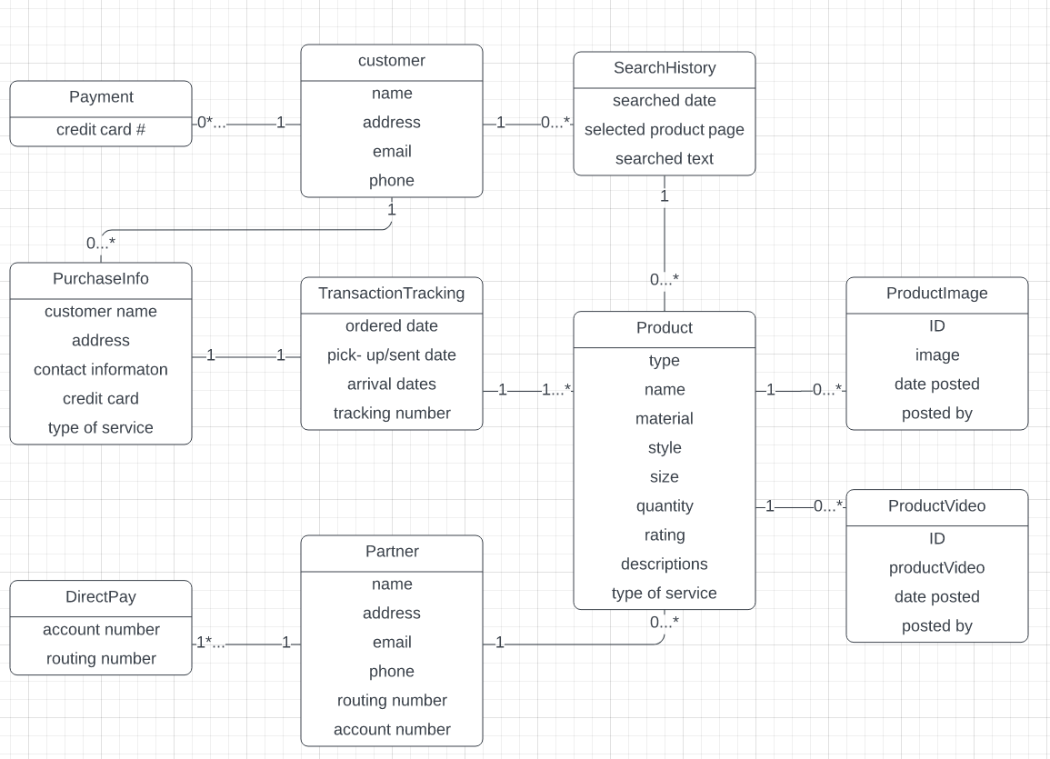

The diagram above illustrates the relationships between the various attributes:

* **Customer to PurchaseInfo and SearchHistory:** A customer can have zero or many associated purchases (PurchaseInfo) and browsing activities (SearchHistory), indicating that a customer may make multiple purchases or browse products without making a purchase.
* **PurchaseInfo to TransactionTracking:** Each purchase (PurchaseInfo) is linked to exactly one TransactionTracking record, as every purchase requires its own tracking information. However, a single transaction may involve multiple products.
* **Customer to SearchHistory:** At least one customer is required to generate a SearchHistory record. A single search may return no results or multiple products, reflecting the variability of search outcomes.
* **Product to ProductImage and ProductVideo:** A product does not necessarily need to include images or videos, but there must be at least one product in the system for these attributes to exist.
* **Partner to Product:** The relationship between Partner and Product is one-to-zero-or-many. This means individuals can register as partners without being required to offer a service or upload a product, though they have the option to do so.